CHAT BOT IN FOOD INDUSTRY

***Abstract*—** Chatbots are widely popular now-a-days and catching speed as an application of computer communication. Some programs respond intelligently like a human or similar to a human. Such a program is called as a Chatbot. There are generally two types of chatbots- a rule-based bot which works on keywords using ‘Natural Language Processing’ and the other is a complete ‘Machine Learning and Deep Learning’ based bot. This paper addresses the design and implementation of a Chatbot system in the food industry i.e. a bot in a restaurant who will perform the complete task of taking up orders and bringing it back at your table saving up your waiting time.

***Keywords—*** Chatbot; Communication; Food Industry; Natural Language Processing.

# I. INTRODUCTION

|  |
| --- |
|  |

In today’s world computers play an important role in our society? Computers give us information; they entertain us and help us in lots of manners. A chatbot is a program designed to counterfeit a smart communication on a text or spoken ground. This paper is based on a ‘Food request accepting chatbot.’ The bot accepts order requests from the customers and sends it to the web page of the restaurant from where the hotel staff gets the idea of what and when is the customer arriving and ordering the food. Once the order is received, the hardware part of the bot takes care of delivering your favorite item right at your table. A chatbot is basically a software that resides on a messaging platform and is developed with the purpose of having lifelike interactions with humans through text or audio.  
But how can these bots contribute to restaurants, you ask?  
Suppose you feel like having your favorite pizza but your order is taking up too much time at the pizza joint. Wouldn’t it be great if someone magically delivered your pizza? Well, we don’t have pizza delivering robots as of now, but we have the next best thing – bots.

# 

# II. DESIGN

The designing and development of this system can be divided into three major domains- Web development, Natural Language Processing based software development and IoT. The first domain refers to a website/webpage developed for the UI (User Interface). A python program provided with a pre-requisite restaurant dataset/database, to train the bot based on NLTK (Natural Language tool kit), is linked to this webpage using ‘Flask’ framework of python which is used to link python programs to webpages to display results on them and vice-versa. This framework was chosen by us over the more popular and preferred ‘Django’ framework, simply because of its easier syntax and lesser complexity. The third domain refers to the connectivity to the ‘Hardware bot’ which works on the principles of IoT (Internet of Things). The bot, on receiving an order, follows a path up to the kitchen, waits for a certain interval of time and then brings the order back at the customer’s table.

-

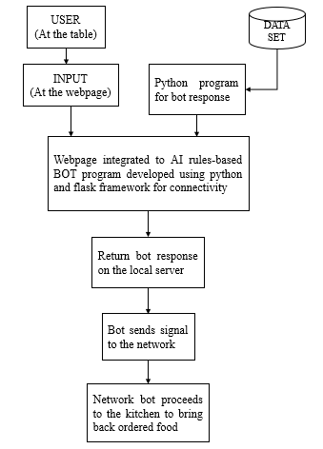

Fig.1: System architecture

The following facts are kept in mind during designing and development process:

## A. Selection of OS

Windows is used for this project because it is user friendly. It is also robust.

## B. Selection of Software

‘Brackets text editor’ software is used for creating python programming as well as web development, because it is open source with a basic workspace and lesser complexity.

## C. Creating a Chatbot

For creating a Chatbot, a program has to be written. Python programming language is used for programming. The Chatbot is created in such a way to help the user, improve the communication and amuse the user.

## D. Creating a Chat

The chat is created using a pattern that is known to the user and could be easy to understand. This chat is stored as a text/.yml file and serves as the database on which the chatbot is trained.

## E. Pattern Matching

It is a technique of artificial intelligence and NLP used in the designing process. The user input is matched with the inputs saved in the database and corresponding response is returned.

## F. Simple

The design of a Chatbot is very simple. It just answers to the questions asked by the user, if similarities are found in the database.

## G. Conversational and Entertaining

The Chatbot responses are a way known to the user. The conversation follows a Basic English language and interacts in an easy to read manner. The conversation between the user and the Bot is entertaining. It is like talking to another person.

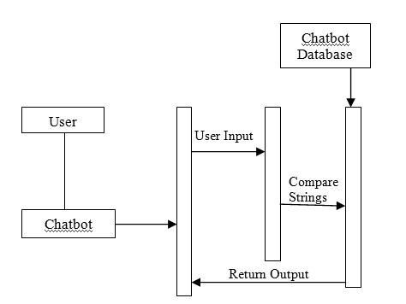

Fig. 2: Sequence Diagram Representing Design of the Chatbot.

**III. IMPLEMENTATION PROCESS**

The first and foremost process was collecting data/creating a database. We researched about various cuisines and food items/dishes and also the conversations taking place at a restaurant. Then, the entire data was stored in a.txt/yml file. Yaml or .yml files are like json files, except that they are more user-friendly and dynamic. One can store data as objects or lists or dictionaries, etc. in .yml files. After data collection, the program to implement the bot response was written in python. Python offers a number of libraries and frameworks free of cost to use and implement as per our needs. We have used the ‘chatterbot’ module to train the bot based on keyword pair matching from the dataset. The bot variable is assigned to the ‘Chatbot’ package of the chatterbot library. The trained data is then sent to a conditional loop, where response from the bot is generated based on user input.

After generating responses on python platform, it was time to develop a UI where the user input and corresponding bot response will be displayed. For this, we used ‘Flask’ framework of python. The framework uses ‘routing’ method i.e. result to be displayed on a particular webpage is provided with the name of the web file along with the route to be accessed (example: for accessing the home page, route- ‘/home’ would be provided, likewise for ‘About’ page, ‘/about’ route would be provided). The framework is imported and accessed in the same python file and the user input and bot-response logic is implemented within the ‘routing to our page’ portion of the program. On executing the program without errors and bugs, the page is displayed on the ‘localhost’ server having a port number (generally 5000, but one can change it if required). Another important thing to not here is that we can route as many pages we want for a website using this framework, however, in our case, we just have one webpage to be addressed. The page has a section for chatting with the bot. A user can input anything he/she wishes to and will get an immediate response from the bot which is displayed on the same page. The scope covered by the bot is limited, so it is more likely to send some vague message if the user input is out of its scope. As soon as the order is made, the bot can send the signal to the built hardware module.

The hardware bot, built using IoT technology, is basically a wireless car with IR (infrared sensors) at the front to detect the path to follow. The core of the hardware is an Arduino Uno board connected to a motor shield to control movements and programmed in such a way that it follows a specific path up to the kitchen area. For sending response from the webpage to the hardware bot, ESP8266 Wi-Fi module is used. On receiving a signal, the hardware bot follows the path built up to the kitchen area, waits for a certain time interval and returns to the customer’s table with the order.

Some important libraries/modules/frameworks used:

*Chatterbot:* ChatterBot is a Python library that makes it easy to generate automated responses to a user’s input. ChatterBot uses a selection of machine learning algorithms to produce different types of responses. This makes it easy for developers to create chat bots and automate conversations with users. An utrained instance of ChatterBot starts off with no knowledge of how to communicate. Each time a user enters a statement, the library saves the text that they entered and the text that the statement was in response to. As ChatterBot receives more input the number of responses that it can reply and the accuracy of each response in relation to the input statement increase. The program selects the closest matching response by searching for the closest matching known statement that matches the input, it then chooses a response from the selection of known responses to that statement.

*Flask:* Flask is a lightweight WSGI web application framework. It is designed to make getting started quick and easy, with the ability to scale up to complex applications. It began as a simple wrapper around Werkzeug and Jinja and has become one of the most popular Python web application frameworks.

# IV. USE IN FOOD INDUSTRY

## Bots as virtual assistants for restaurants

If a restaurant owns a chatbot that handles your customer interaction can be beneficial for a business. A chatbot can overcome a lot of challenges that are difficult to tackle using any manual process. Here are some challenges that bots can address and act as your companion and not just some nerdy piece of code:  
1: Sluggish delivery and order processing.  
2: Incapable of knowing order patterns for frequent customers.  
3: Unable to keep track of loyal customers.  
4: No customer feedback to assess performance based on analysis and reporting.  
5: Customer preference is not taken into consideration while presenting the menu.

# V. FUTURE SCOPE

Chatbots are also referred to as virtual assistants. It is a rudimentary form of artificial intelligence software that can mimic human conversation. The Chatbots can be analyzed and improved. It can be used in various fields such as education, business, online chatting etc. It can be used in the field of education as a learning tool. The information necessary for education can be stored in the data base and can be retrieved any time by querying the bot. In business field, it can be used to provide business solutions in an efficient way. When the solutions are efficient, the business can be improved and the growth of the organization will be increased. This Chatbot can be used in online chatting for entertainment purpose. People can chat with these bots online when they are bored for the purpose of entertainment. These bots can also be used to learn different kinds of language. The language that has to learnt can be stored in the database and can be learnt by asking questions to the bot. They can also be used in the field of medical to solve health related problems. Chatbots are going to explode and can be really dominating in future. Chatbots can provide a new and flexible way for users. They are giving AI something better to do. Chatbots results in smart conversation and is advancing at an unprecedented rate with each new development. ChatBots usually store contextual data which can be used in the detection of geo location or a state (which data is needed for which step when communicating with a bot?). This could also be a telephone number or other private data, and no one knows whether the data is encrypted before it gets saved to a database. Since Chatbot predicts and provides accurate response to a posed question, it is hard to imagine the future without a Chatbot.

# VI. CONCLUSION

A chatbot is used as a virtual medium in our project to order food. In this paper, information about the design and implementation of a chatbot in food industry has been presented.

# VII. REFERENCES

# How bots can solve the 5 most common restaurant industry challenges

## [Riya Savjani](https://www.softwebsolutions.com/author/riya/)   *POSTED:*September 29th, 2016